Australian Tasar Council Inc

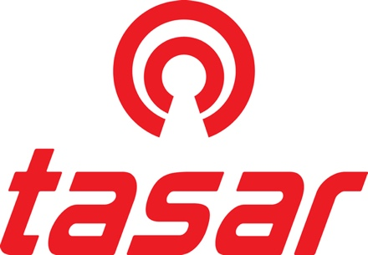

Annual General Meeting – 2022
Port Lincoln Yacht Club -Tuesday 04/01/2022

Meeting Opened 10:06 am

Present:
Members: Nicole Kidman (ATC President), Stuart Templeton (TASA President-ATC Measurer), Blaise Vinot (ATC Secretary-TAV President), Rebecca Nicholson (TASA Secretary), Hugh Tait (TANSW President)
Observers: Chris Payne (WTC Measurer), Heather McFarlane (VIC), Adrian Nicholson (SA), Jenny Sorensen (NSW), Kate Vinot (VIC), Imogen Martin (VIC), Andrew Martin (VIC), Ralph Stanford (NSW), Neil Long (NSW), Chris Dance (VIC), Claire Medd (VIC), Simon Medd (VIC), Bern Streater (NSW)

Apologies: None received

Minutes from the last AGM held in December 2020 by zoom conference were confirmed
Moved Nicole Kidman, Seconded Hugh Tait - Passed.

Reports
  - President report delivered as a separate statement
Moved Hugh Tait, Seconded Jenny Sorensen - Passed.
  - Secretary/Treasurer – Finance statements presented and accepted.
Moved Blaise Vinot, Seconded Ralph Stanford - Passed.
  - Measurer – Report delivered as a separate statement
Moved Stuart Templeton, Seconded Andrew Martin - Passed.

Discussion on measurer’s report:
- Minimum crew weight rule. General agreement is that minimum crew weight rule is obsolete. BV confirmed that data from Victoria was supplied to WTC secretary.
Action: Chris Payne to check who needs to put a motion in to change the minimum crew weight rules.

- NSW indicated that they are offering to subsidise 3 members (who will commit to being measurers at the NSW Nationals in 2022-23) to attend a measurer’s course organised by Australian Sailing and held at Georges River 16ft Sailing Club.

Annual Levy

The ATC executive proposed that there be NO increase in the Nationals Levy, charge to remain at $20 per boat. The state levy is also to remain at $15 per boat. All agreed.

Districts Business

NSW: Hugh Tait gave an update on the jib sheet trial conducted by Brad Stephens. It looks like the modification will give no advantage in performance but there is still a bit of work to be done to avoid having to move position of the tracks to keep proper sheeting angle.
Stuart Templeton indicated that WA is also trialing a different system.

Next National Titles

Confirmed 48th National Titles will be held from 29/12/20121 to 06/01/2023 at Toronto Amateur Sailing Club, NSW. Organisation will be done by TANSW.
Moved Neil Long, Seconded Kate Vinot - Passed.

Blaise Vinot indicated that pending ratification the 49th National Titles will be held at Sandringham Yacht Club, VIC from the 28th to the 30th of December 2023 as a pre-regatta to the 2024 Worlds.

Open Members and Executive Positions

Nicole Kidman (President) and Blaise Vinot (Secretary/Treasurer) are midway through their 2-year term. No elections were held.

No open member was proposed by the districts.

World Executive Report

Seattle Worlds have been postponed to September 2022. USA organisers have asked Australia to explore sending charter boats for Japan and possibly Europe due to astronomical container shipping costs. They also offered billeting for all international competitors.

Special resolution:
That the committee approves the modification of the constitution as presented to be submitted to Consumer Affairs Victoria for ratification
Moved Blaise Vinot, Seconded Nicole Kidman, all in favour - Passed

Meeting closed 11.08 AM

Blaise Vinot
Secretary/Treasurer
ATC

